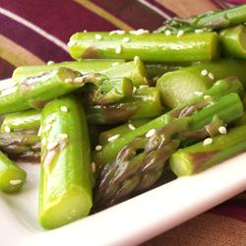
Spring Asparagus Salad
"This is a nice and simple cold salad that is nothing more than asparagus dressed in a Chinese-influenced vinaigrette topped with sesame seeds. It's a great way to celebrate the arrival of the asparagus crops!"

Ingredients:
1 tablespoon rice vinegar
1 teaspoon red wine vinegar
1 teaspoon soy sauce
1 teaspoon white sugar
1 teaspoon Dijon mustard
2 tablespoons peanut oil
1 tablespoon sesame oil
1 1/2 pounds fresh asparagus, trimmed and cut into 2-inch pieces
1 tablespoon sesame seeds
Optional Ingredients:

- Water Chestnuts
- Grape Tomatoes
- Green Onions
- Mushrooms
- Chopped Pecans
- Baby Corn

Directions:
- Whisk together the rice vinegar, red wine vinegar, soy sauce, sugar, and mustard. Drizzle in the peanut oil and sesame oil while whisking vigorously to emulsify. Set aside.
- Bring a pot of lightly-salted water to a boil. Add the asparagus to the water and cook 3 to 5 minutes until just tender, but still mostly firm. Remove and rinse under cold water to stop from cooking any further.
- Place the asparagus in a large bowl and drizzle the dressing over the asparagus. Toss until evenly coated. Sprinkle with sesame seeds to serve.

